
Land Information Ontario (LIO) Warehouse
Data Class Name: Provincial Park Zone
Documentation
Produced by: Information Access and Information Management Policy Unit
Ministry of Natural Resources and Forestry
Date: July 27, 2015

Purpose

This document provides additional information to support the use of geospatial data. The Physical Model Diagram provides a visual representation of the relationships in the data class. The Data Change History lists all the modelling and access changes that have occurred during the lifecycle of the data class. A data description identifying table and field names is available upon request.

Need Assistance?
Please contact LIO Support at lio@ontario.ca or 705-755-1878 if you require help.

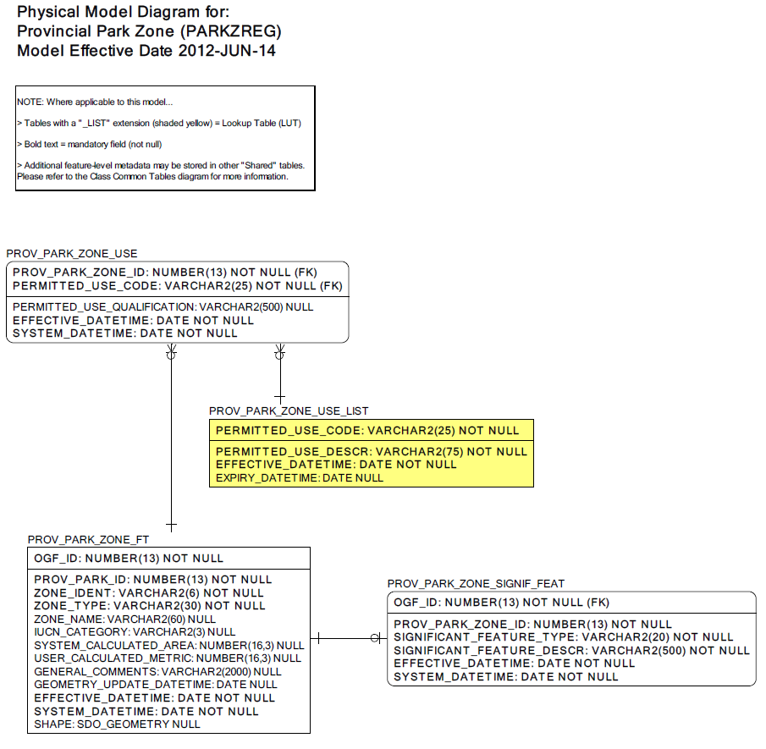

Data Class Change History

Data Class Name: Provincial Park Zone
Data Class Short Name: PARKZREG
Date  YYYY-MM-DD | Details of Change
2014-10-14 | Value added to valid values list for PROV_PARK_ZONE_FT. ZONE_TYPE.  Value of “Unknown” was added to existing valid values list.
2005 | Table Added: PROV_PARK_ZONE_USE  New table contains information such as permitted use code, use restrictions and associated park FMF_OBJECT_ID.
2005 | Attribute Added: PROV_PARK_ZONE_FT.ZONE_TYPE  Valid values list includes : Access, Development, Historical, Natural Environment, Nature Reserve, Recreation, Recreation/Utilization, Wilderness
Data Description
Please refer to the metadata record for the data description.

